**HANGMAN GAME**

**Documention by Manjurekha Badiger**

- Date of submission : 23 Dec 2022

- Customer's vision: To have Hangman game with 4 to 5 players play sametime together and have there own hangman and each one wish to others oldman should be hanged.

- link to the group's github repo- <https://github.com/alkafri/fabulous-stars-hangman>

. **Reflection:**

My reflection in working on Agile development team is that working closely with group and problem solving within the group was good. I was working on Kanban mediating on requirements and prioritizing requirement. I worked on canvas and code on add controls to buttons and alerts notifications.

1. As a developer I want to add a controls such as button, text field, register event for that so that user can add guess word and letter to guess and submit the input to play the game.

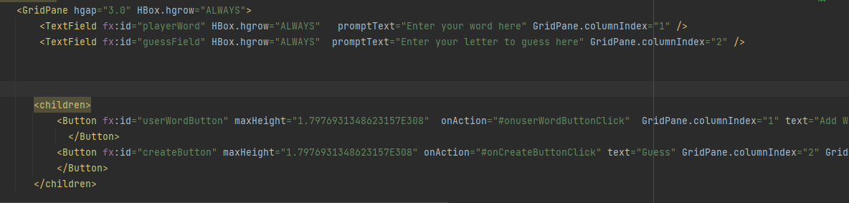

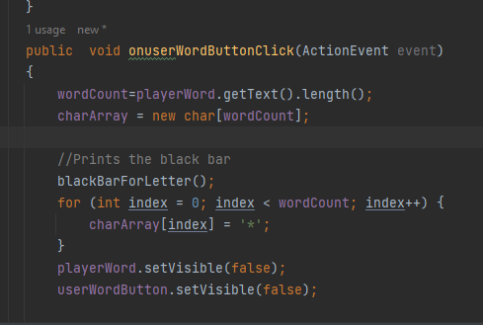

2.As a developer Julius wanted to build canvas for game to be displayed on canvas so that its visible to players to play game.

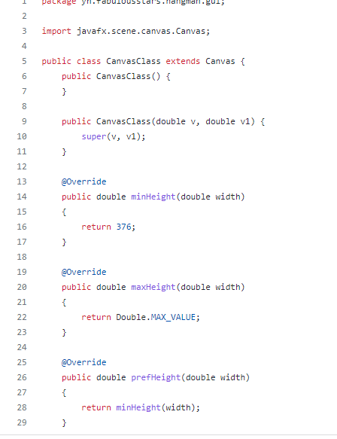

3.

As a Developer , Ben wanted to write logic of guessing letter from the word so that we can identify if we have found exact match of the word or else to start the Hangman

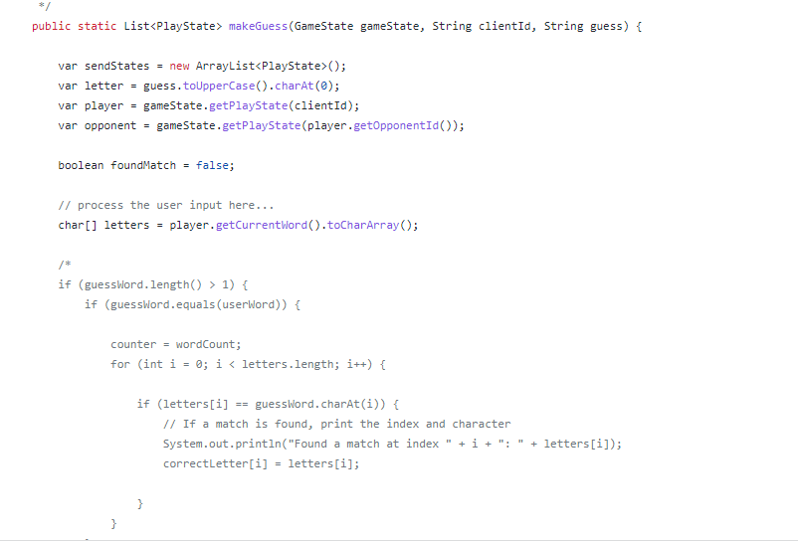

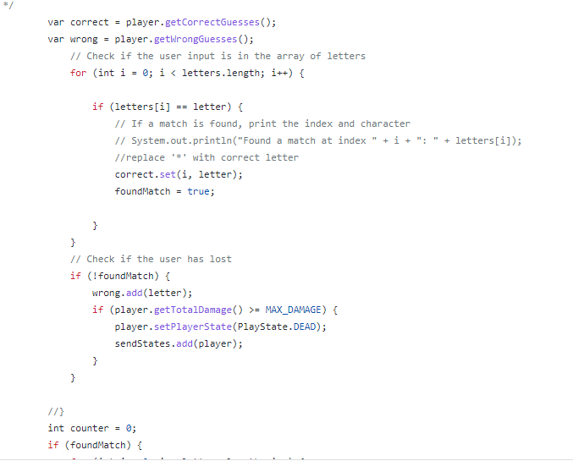

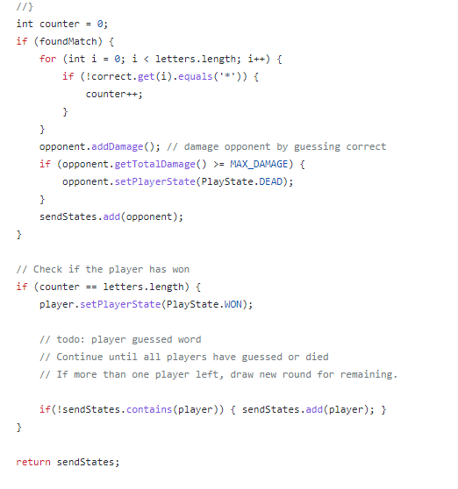

**Termination:**

Group was collabrated daily with daily meeting with scrum and following were discussed

* What i did yesterday and difficuilites if anything faced in it
* What is my plan today to implement
* Backlog managed using Trello kanban any backlog items added , during daily collabration those tasks were divided among us.

We used to mention about pull request and code review in our daily collabration meeting , after code review and solving conflects code was merge into main.

Most diificult problem to deal was 4 players playing hangman game at the sametime, for this retrospect we thought of using server and changes were made to single canvas to canvas for each indiviual player.